**Experiment no:9**

**Aim:** to find the enumeration commands using kali linux commands.

**Commands :**

**1.**enum4linux –h

2.enum4linux –u

3.enum4linux –ukali –pkali –u 192.168.1.1

4.enum4linux 192.168.1.1 –a

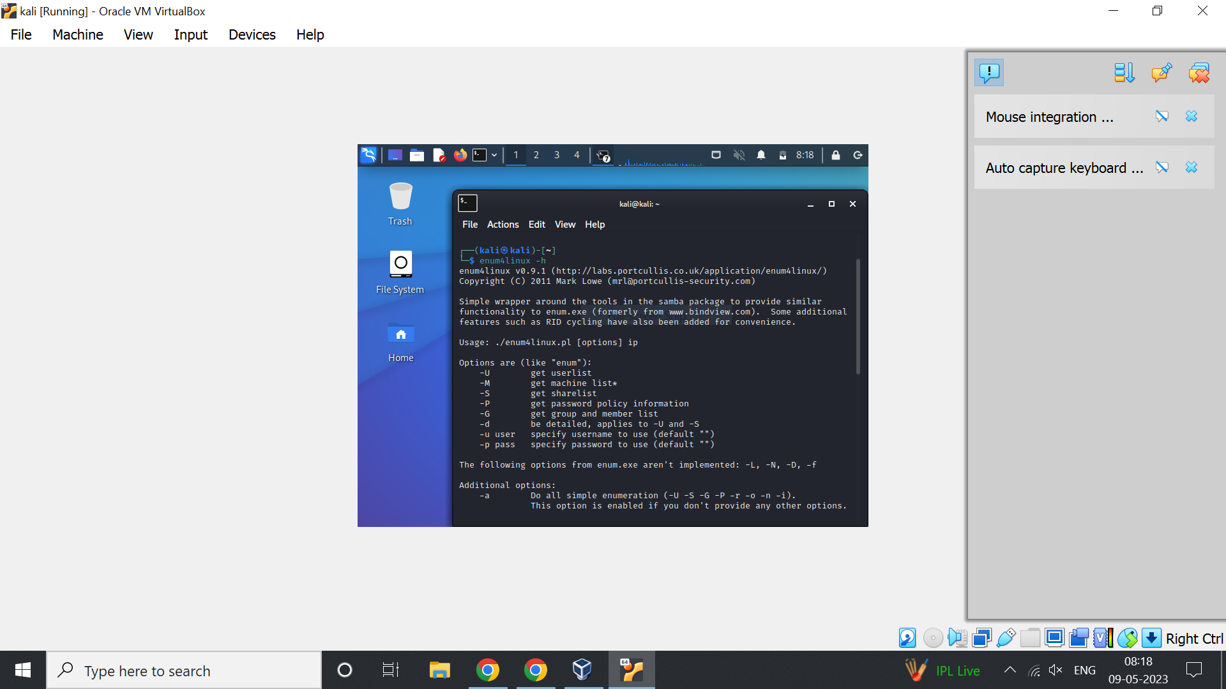

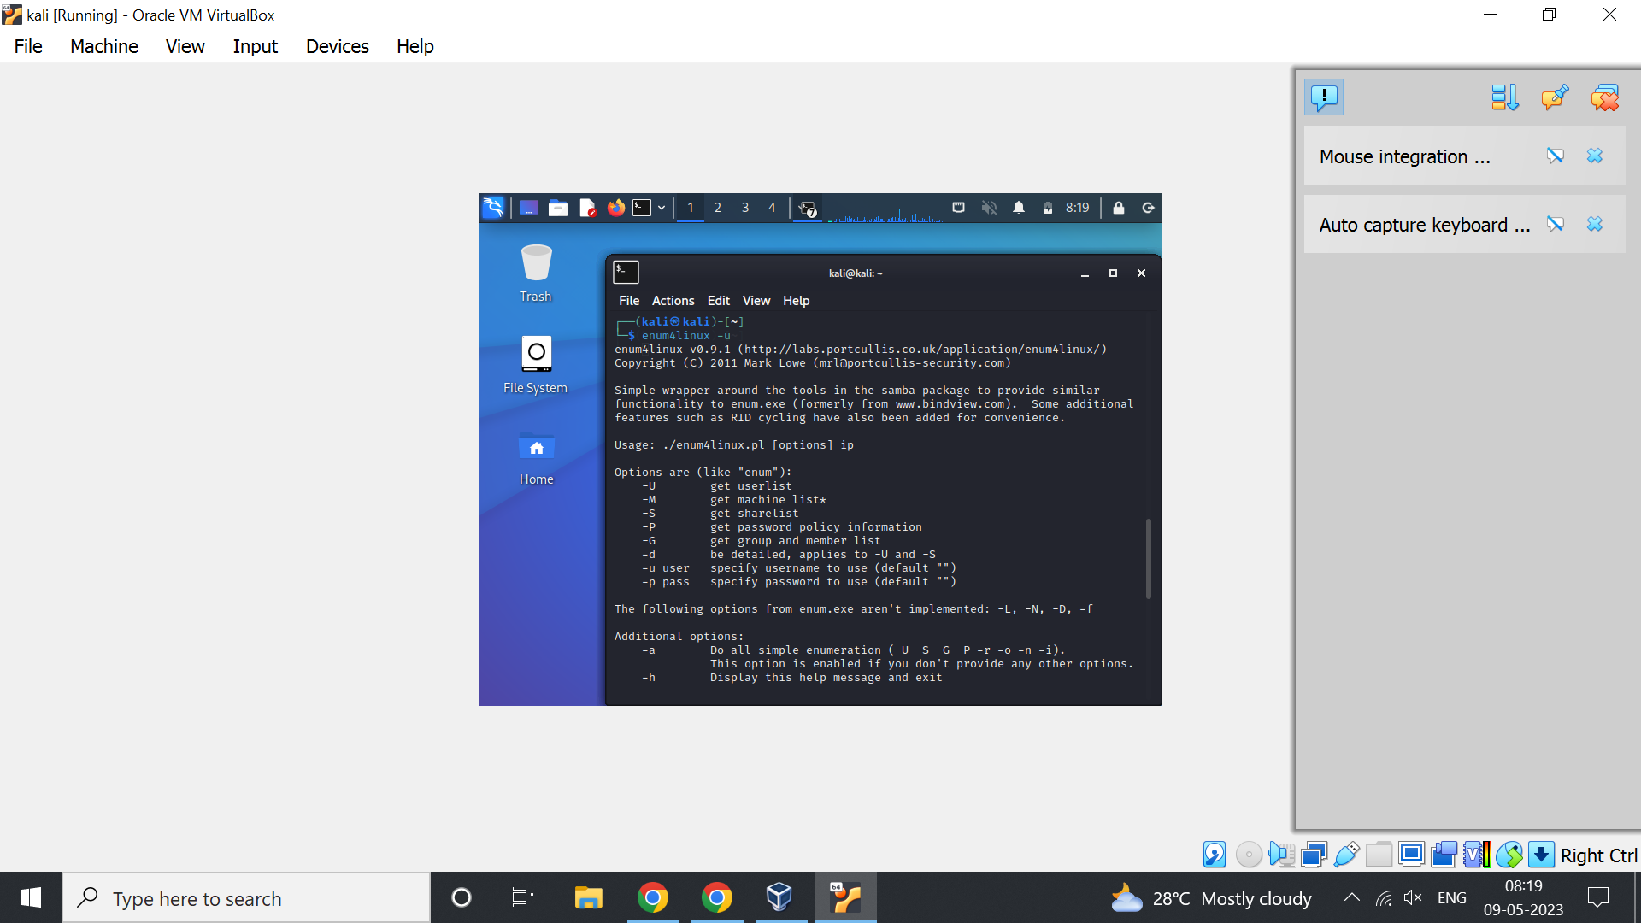

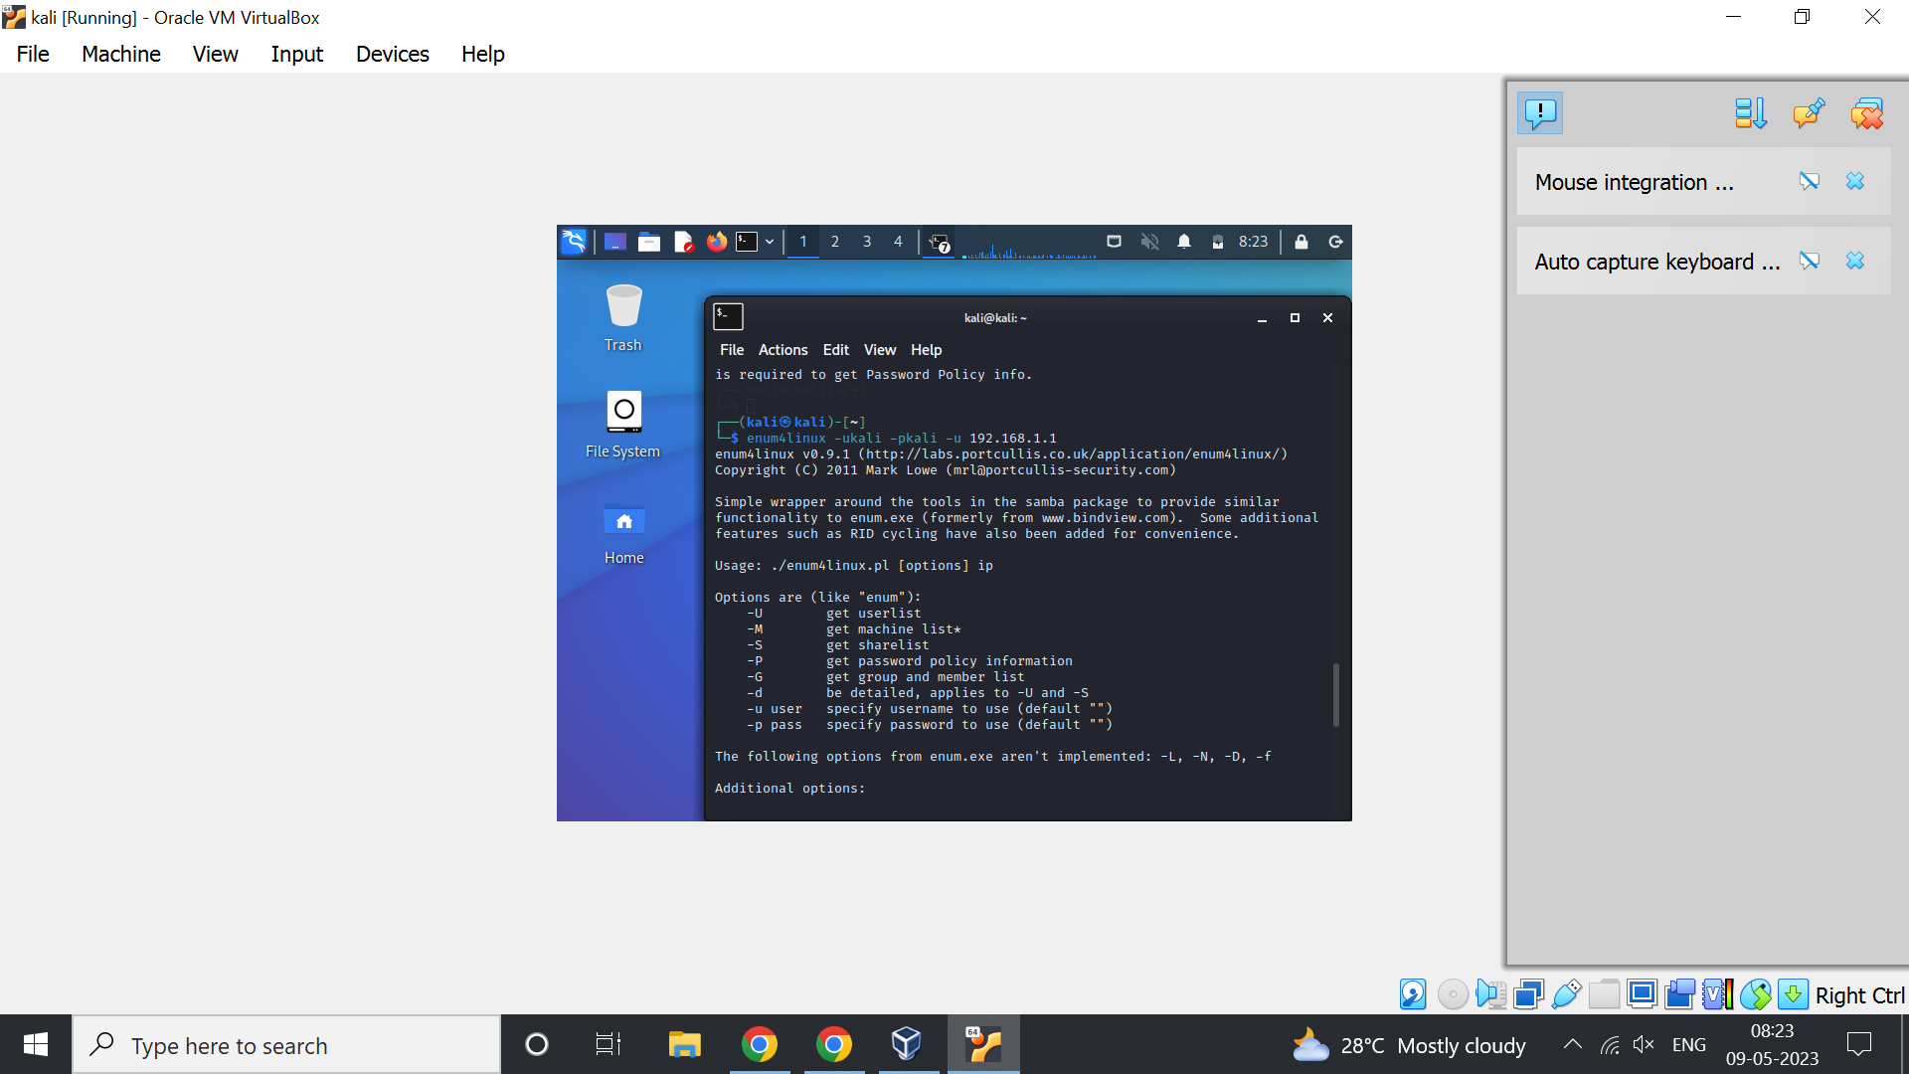

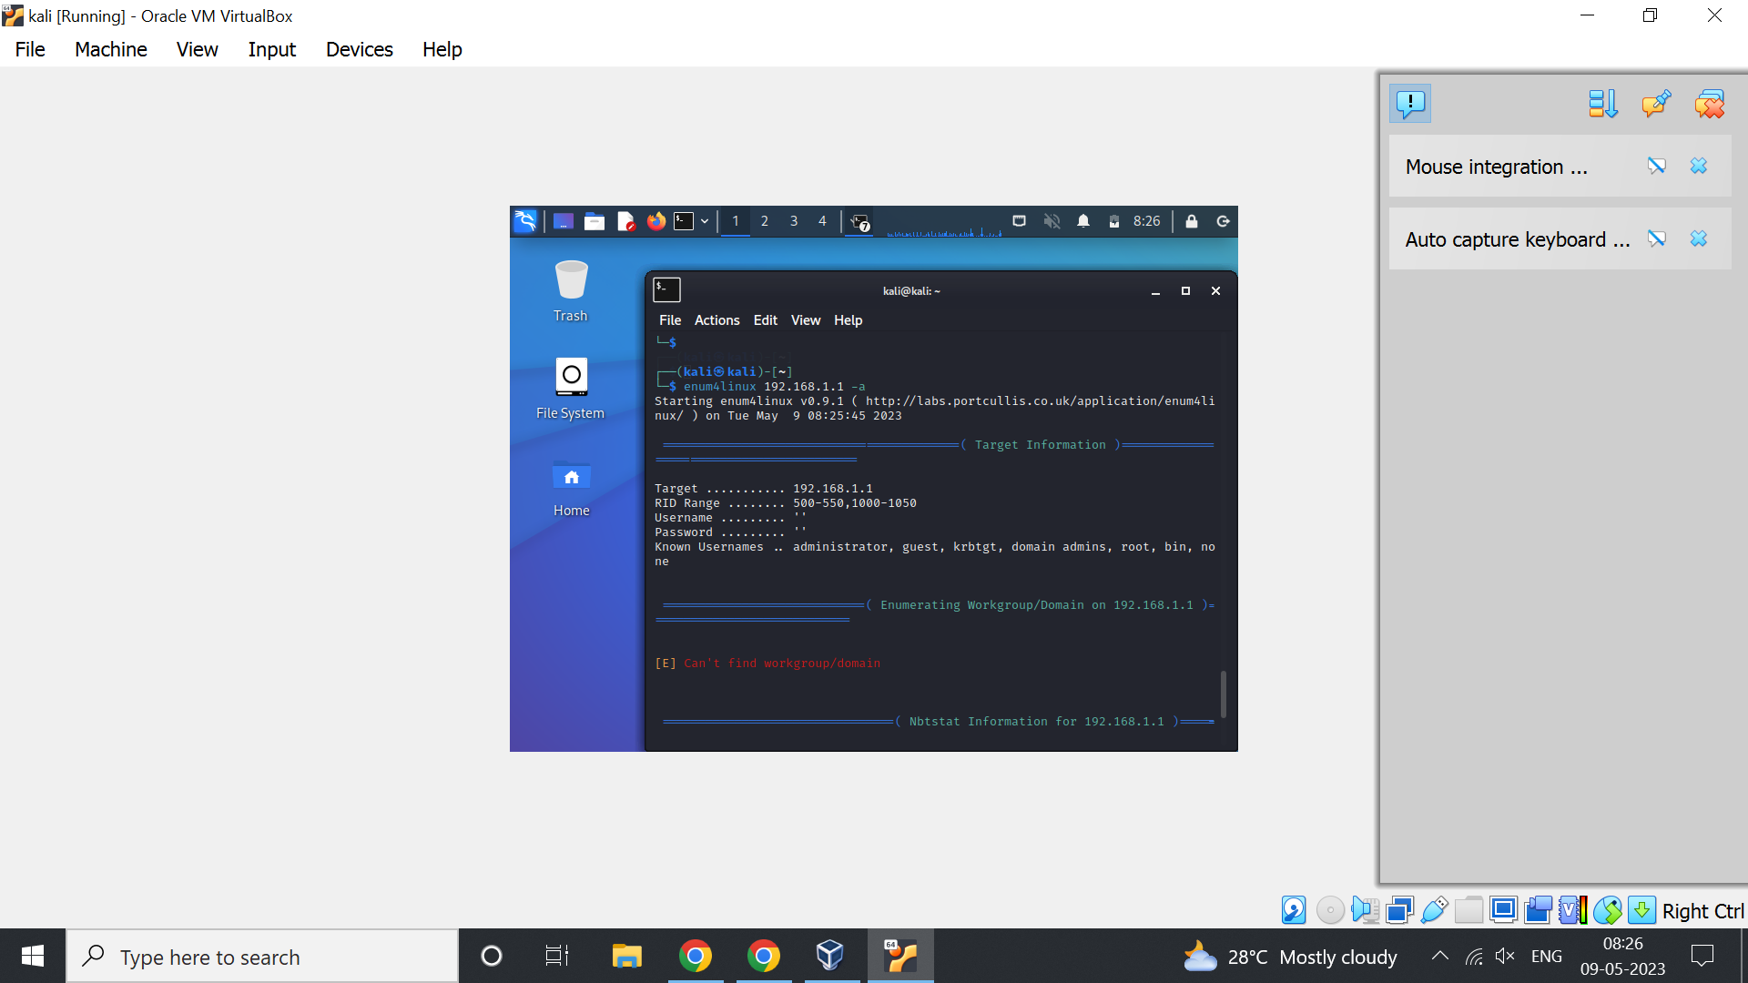

Result :